**Panasonic colour sensor (Panasonic Mark Sensor LX-100)**

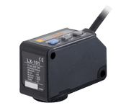

The LX-100 series - a combined LED contrast and colour sensor - can be used both as a high-speed contrast sensor to quickly and reliably detect printer's marks, for example, and as a high-precision colour sensor.

In contrast sensing mode, the sensor automatically selects the optimum emitting LED during teach-in (static or dynamic teach-in method) from the transmitting light source (red, green and blue LEDs). With a response time of just 45µs, this sensor is perfect for high processing speeds like those required in printing presses, for example. In colour mode, an integrated microprocessor with a 12-bit A/D converter digitally processes the signals of the colour to be detected in red, green and blue primary colour components. This ensures that even the most minute colour differences or merest of tints can be accurately distinguished.

The Panasonic color sensor has two working modes on which it can be made to work in order to detect the color the two modes are as specified Below

1. Mark Mode- This mode is used where we need faster colour sensing rather than precise sensing (E.g. this mode needs a good contrast between colors for distinction)/
2. Colour Mode-This mode is used where we need accurate sensing rather than speed. Eg this mode is highly important to distinguish colors having low contrast ratio.

Hence both the mode have its own use as and when required and as per the level of our problem statements.

Working:

1. Mark Mode:

This sensing mode automatically selects a single color from the 3 R・G・B LEDs to achieve an ultra quick 45 μs response time. The automatic optimal LED selection function automatically selects the LED that is most suitable for the sensing. This function is perfect for ultra quick sensing.

The 3 colors of the R・G・B LEDs are optimally selected according to the color combination. With the LX-100's Mark mode, the built-in "Automatic optimal LED selection function" automatically selects the LED for the largest contrast (S / N ratio) between the mark and base (non-mark area) to ensure optimal sensing. For more stable detection, the sensor makes selections according to the contrast and not according to the reflected light variation between the mark and base (non-mark area).

[The example on shown below deals with reflected light on packing film.

Great figures are indicated for the blue LED's light amount ratio and, for even more stable sensing, the blue LED effectuates this mark sensing.]

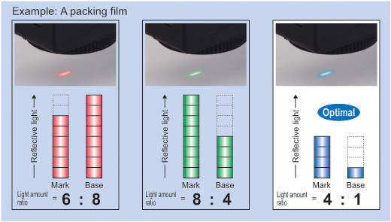

**Hence the color having the highest light amount ratio will be considered as optimal in the mark mode and we will use that as our reference led for detecting the color at that instant.**

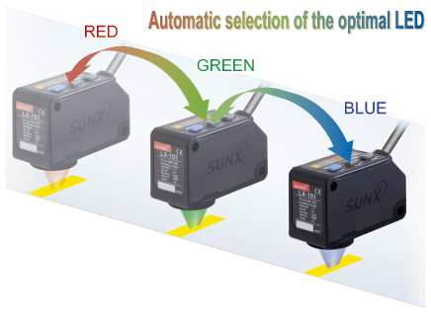

1. Color mode [High precision discrimination]  
   All 3 R・G・B LEDs light up and high precision mark color discrimination occurs using the R・G・B reflective light ratio. This function enables effective detection of films with patterns around the area of the mark.

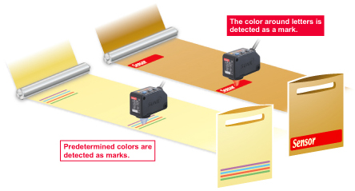

The Color mode on the LX-100 series utilizes all 3 R・G・B LEDs to determine the R・G・B ratio of the mark color.

The built-in 12-bit A/D converter enables high precision 1/4,000-resolution judgments. The figure below is a graphic description of this process.

High precision mark color discrimination

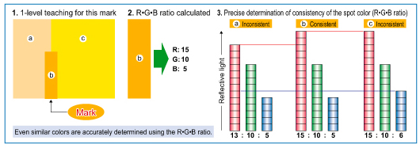

An Rgb ratio is said to be consistent if the ratios of R,G&B can be express as an integral of each other i.e ratio of R= K . ratio of B Where K is an Integer

**Internal Structure and circuit of the Sensor**

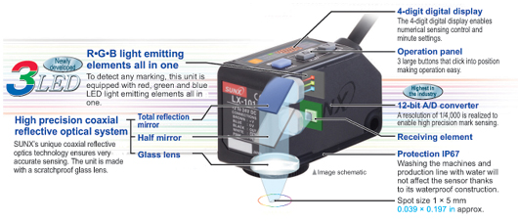

**Characteristic:**

* Three different emitting LEDs (red, green, blue)
* High precision coaxial reflective optical system
* High resolution 12-bit A/D converter
* 4-digit digital display
* Teach-in for simple settings (external teaching also possible)
* Timer function (ON/OFF-delay)
* Two inverse outputs (cable type)
* Compact size
* M12 or cable type
* IP67

**Accessories:**

* For connector types: 2m or 5m cables
* Mounting brackets

**Specifications**

|  |  |
| --- | --- |
| **NPN output** | **LX-101 (Z)** |
| **PNP output** | **LX-101P (Z)** |
| Sensor type | Mark and colour sensor |
| Timer function | 1 - 500ms |
| Sensing range | 10 ± 3mm |
| Spot size | 1 x 5mm |
| Response time | Max. 45µs (mark mode), max. 150µs (colour mode) |
| Output transistor | Max. 50mA (2x, cable type), max. 100mA (connector type) |
| Emitting diode | Red (640nm) , blue (525nm), green (470nm) |
| Power consumption | Max. 30mA |
| Housing material | Plastic |
| Protection | IP67 |
| Size (H x W x D) | 57 x 24 x 35mm |
| Connection | Cable 2m or M12 connector = (Z) |
| Supply voltage | 12 - 24V DC (± 10%) |
| Ambient temperature | - 10°C - + 55°C |
| Weight (approx.) | 120g (cable type), 55g (connector type) |

**Typical applications**

[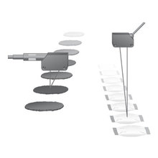](https://www.panasonic-electric-works.com/pew/eu/images/sensors/ap_63100_7201_lx100_1_rdax_220x220.jpg)

Colour detection

[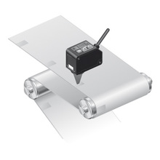](https://www.panasonic-electric-works.com/pew/eu/images/sensors/ap_63100_7201_lx100_2_rdax_220x220.jpg)

Mark detection

[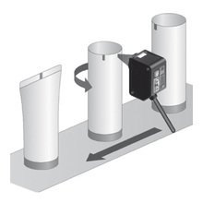](https://www.panasonic-electric-works.com/pew/eu/images/sensors/ap_63100_7201_lx100_3_rdax_220x220.jpg)

Contrast

**Interfacing the LX100 With Arduino**

The LX-100 GIVES A OUTPUT SIGNAL BETWEEN 0-15V which cannot be fed directly into Arduino as it accepts signals only between 0-5v Hence we need to use buck convertors to step down the signal between 0-5V and then feed it into the Arduino for processing. Similarly to use it with a beaglebone we need to step it down to 3.3V so that it can be fed into the analog inputs of the board else it will damage the board.